Evergreen Offline Circulation for Migration
During the downtime when you cannot connect to the Evergreen staff client.
- Locate the Evergreen icon  on your desktop that access bark.cwmars.org.
- Double click to open the client login screen. BE SURE THE HOSTNAME IS bark.cwmars.org.
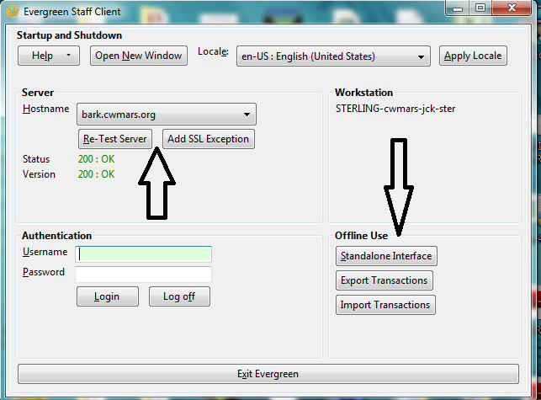
If the host name is NOT bark.cwmars.org you have opened the wrong client. Click x to exit. Locate the Evergreen icon on your desktop that has the address of bark.cwmars.org.
- After verifying the host name is bark.cwmars.org, click Standalone Interface to enter Evergreen Offline Circulation.

If you encounter this error, click OK to continue.
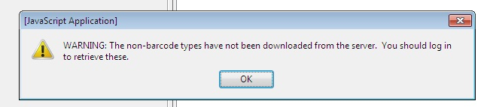

EVERGREEN OFFLINE CIRCULATION INSTRUCTIONS
Reminders:
- You must have the patron’s barcode to check out items.
- It is best to check in items after the system is back up live. If the system finds an exception to an item such as an item note “check for 6 CDs”, the item will be listed on a report but not checked in.
Checkout
- Click Checkout at the top of the screen and follow the directions on the left.
- Enter the patron’s barcode, enter the due date (or select a loan period), enter the item barcode and click Enter. You do not need to click the Check barcode? boxes as there will not be a system online to check.
- Repeat these steps for each additional item the patron is checking out.
- When done, click Save these transactions.
- Remember that this information is merely being recorded to be processed later, after migration. Checkouts will be accepted regardless of the patron’s expiration date, fines, etc.
Check In
- Click Check In at the top of the screen and follow the directions on the left.
- Enter the item barcode and click Enter.
- Repeat this step for all items being checked in.
- When done, click Save these transactions.
- Remember that this information is merely being recorded to be processed later, after migration. Checking in items will not trigger holds or other actions that require reference to the online system. Overdue fines will be assessed as appropriate after uploading.
Renew
- Click Renew at the top of the screen and follow the directions on the left.
- Enter the patron barcode (optional), enter the due date (or select a loan period), enter the item barcode and click Enter.
- Repeat these steps for all items being renewed.
- When done, click Save these transactions.
- Remember that this information is merely being recorded to be processed later, after migration. A renewal will be accepted regardless of holds, maximum renewals, etc.
Patron Registration
- Please note that C/W MARS does not recommend registering patrons in the Offline Interface. There is no way to search for the patron initially to see if they already have a C/W MARS patron record.
- If registration is necessary and the new patron wants to check out items, be sure to register them before checkout. Offline transactions are loaded in chronological order, so if checkouts are loaded before registration, the patron barcode will not be recognized.
- Click Register Patron at the top of the screen.
- Choose the appropriate Home Library from the dropdown menu.
- Fill in the appropriate information.
- When done, click Save patron registration at the bottom right of the screen.
- Be sure to make a note about the patrons you register. The offline registration form is incomplete, so you will need to go to the patron record after migration to fill in the remainder of the information.

